Phosphorus Removal of Nannochloropsis with Varying Environmental Salinity

Class # 39

# Table of Contents

**Table of Contents** **1**

**Introduction** **2**

Research Question 2

Background 2

Phosphorus in wastewater 2

Phosphorus and Algae 4

**Variables** **4**

Independent Variable 4

Dependent Variable 5

Constants and Controlled Variables 5

**Hypothesis** **5**

**Method** **6**

Materials 6

Procedure 6

Preparing Culture Media 7

Preparing Cultures 7

Taking Phosphorus Measurements 8

Running the Experiment 8

Safety 9

**References** **10**

# 

# Introduction

This internal assessment explores the application of algae in wastewater treatment, specifically for its uses in the removal of phosphorus from wastewater.

Both of my parents used to work in the landscaping business, managing gardens and designing landscaping infrastructure for projects. Growing up surrounded by these projects, I became very familiar with how plantlife interacts with the environment and our local ecosystems. As I learned more about the science behind plants and their role in ecosystems, I began to connect the dots in my head, and build an understanding of some of the problems threatening our environment in terms of plant life and its interactions with humans. One of the pressing issues in this field is how environmental phosphorus is used and reused, and how we are running out of phosphorus.

## Research Question

The research question for this internal assessment is: for the nannochloropsis species of algae, how do environmental salinity levels affect the rate of phosphorus removal from its environment?

## Background

Phosphorus is essential for life, as it is a key component of DNA and is necessary for many metabolic processes (Kroiss et al., 2011). However, phosphorus is a non-renewable resource, and as populations of living organisms continue to grow, the total phosphorus needs of the planet will grow as well. This brings to light the importance of phosphorus reclamation initiatives, as the current, dissipative usage model of phosphorus in our society is unsustainable.

### Phosphorus in wastewater

One of the largest sinks of phosphorus currently is in wastewater from agriculture. Phosphorus is used as plant fertilizer, and is added by farmers to boost crop health and yields. From here, though, phosphorus can be moved into runoff or into wastewater through surface runoff and subsurface flow (Sharpley & Beegle, 2001). Because of this, only around 10% of the phosphorus used in agriculture is contained in the food produced.

This presents an amazing opportunity for phosphorus reclamation in agricultural wastewater, for which there are many more traditional methods: precipitation through chemical dosing, absorbative media, and ion exchange technologies (Bunce et al., 2018).

In the precipitation process, metal salts are added to wastewater to react with phosphorus and precipitate it as a solid, which can then be removed by filtration. However, this can drastically change the pH of the wastewater, requiring the addition of more chemicals to stabilize it before it can be released into the environment (Bunce et al., 2018).

Absorbative media is produced from materials like bauxite or limestone, and removes phosphorus in a targeted manner. However, there have been concerns about the long term effectiveness of these methods (Shilton et al., 2006).

Ion exchange mechanisms for phosphorus removal rely on the anionic nature of phosphorus in wastewater to select and remove it through the use of phosphorus-selective nanoparticles (Zhao & Sengupta, 1998). However, full scale implementations of these systems have been limited due to expensive chemicals, among other things (Bunce et al., 2018).

While there are many established methods of phosphorus removal from wastewater, each has its own advantages and specific drawbacks. Hence, this internal assessment aims to explore yet another method for phosphorus removal, with the use of algae.

### Phosphorus and Algae

As mentioned above, phosphorus is necessary for life. It is an important part of cell membranes, enzymes, DNA, RNA, and ATP. Algae aggregate phosphorus from their environment and use it to develop a larger population (Biocyclopedia, n.d.).

The algae being used in this experiment is of the genus Nannochloropsis. This genus of algae preferes a marine environment, so when preparing culture media and running experiments, f / 2 culture media was used.

f / 2 media replicates a typical environment that marine algae thrive in. It contains many different compounds, trace metals, and vitamins that algae need to survive. Importantly, it contains monosodium phosphate, which acts as the source of phosphorus for the algae. The final molar concentration of phosphate (PO4) in the media is 3.62 * 10^-5 Molar. (*F/2 Media*, n.d.)

# Variables

## Independent Variable

The independent variable in this experiment is the salinity level of the environment that the algae cultures are growing in.

This was measured in grams per milliliter of culture. For a culture of Nannochloropsis, a salt concentration of 2.642 * 10^-2 grams per milliliter is ideal. For the culture size of 315 milliliters, 8.32 grams of salt mixture is required.

The other concentrations tested in this experiment were 1.5 * 10^-2 g/ml, 3.5 * 10^-2 g/ml, and 4.5 * 10^2 g/ml. These map to 4.73, 11.025, and 14.175 grams of salt mixture respectively for a 315 milliliter culture.

## Dependent Variable

The dependent variable in this experiment is the amount of phosphorus the algae cultures remove from their environment within a given time period, in parts per million.

As discussed above, phosphate concentrations in f/2 algae media are relatively low, so traditional methods of phosphate measurement like test strips will not be precise enough for this experiment.

Hence, a low range, colorimetry based phosphate meter from Hannah instruments was used to take phosphate measurement throughout the experiment.

## Constants and Controlled Variables

A control group of algae with the suggested amount of salts will be left unmodified as a control, as well as a baseline for phosphorus uptake.

Many variables were controlled in the process of this experiment, including the following:

* The initial algae population by biomass
* The amount of initial f/2 culture media in each culture
* The amount of sunlight each culture received
* The temperature at which the cultures were grown
* The containers used for each culture were the same (ball mason jar)

# Hypothesis

The hypothesis for this experiment is that as the environmental salinity level decreases, the Nannochloropsis will remove phosphorus from the environment at a slower rate, as Nannochloropsis is a saltwater species of algae and will thrive in an environment with high levels of salinity.

# Method

## Materials

* 12 culturing containers, preferably beakers or similar glassware.
* Balance for dosing culture salts
* 100 ml graduated cylinder
* 25 ml graduated cylinder
* Larger, 4 liter beaker for preparing culture media
* 50 ml of Nannochloropsis inoculum
* 17 ml of concentrated f/2 culture media
* 120 grams of culture salts
* Colorimeter phosphate checker, the Hanna Instruments Low Range Phosphate Checker (HI713) was used.
* 50 Phosphorus reagent packs, the Hanna Instruments Phosphate Ultra Low Range Checker HC Reagents (HI774-25) were used.

## Procedure

This procedure can be split into four distinct parts: preparing the culture media, preparing the cultures, taking phosphorus measurements, and running the experiment.

An image of the experimental setup can be found in appendix A.

### Preparing Culture Media

1. Measure 3785 ml (1 gallon) of filtered water using graduated cylinder, add to beaker.
2. Add 17 ml (or pre-dosed amount if ordered from algae supplier) of concentrated f/2 media solution.
3. Stir for 1-2 minutes to combine, let rest.
4. Take initial phosphorus reading using the method described below.

### Preparing Cultures

1. Wash all culture containers prior to use, allowing them to dry completely.
2. Measure 315 ml of culture media using a graduated cylinder, add to the culture container.
3. Measure salt mixture by weight using a balance, and add to culture.
   1. For the control group, measure 8.2 grams of salt mixture
   2. For the lower concentration, measure 4.725 grams of salt mixture
   3. For the first higher concentration, measure 11.025 grams of salt mixture
   4. For the second higher concentration, measure 14.175 grams of salt mixture
4. Using a graduated cylinder, measure 4.2 ml of algal inoculum and add it to the culture.
5. Swirl culture container for 30 seconds to 1 minute to mix contents.
6. Repeat this process 12 times. Prepare 3 cultures of each salt concentration.

### Taking Phosphorus Measurements

1. Turn the measurement device on.
2. Fill the cuvette with 10 ml of unreacted sample.
3. Insert the cuvette into the checker and close cap.
4. Press the button on the checker.
5. Allow the checker to calibrate.
6. Remove the cuvette and add one reagent pack.
7. Replace the cap on the cuvette and shake for 2 minutes to mix the contents.
8. Place the cuvette into the checker and close the cap.
9. Press the button on the checker again, allow the device 3 minutes prior to measurement.
10. After the minutes the checker will perform the reading and display the results on the LCD.

### Running the Experiment

1. Prepare culture media according to previous procedure. Take initial phosphorus reading after the media is prepared.
2. Prepare cultures with varying salinity.
3. Allow a lag time of 48 hours for the cultures, swirling the cultures every 12 hours to mix.
4. Ensure that all are exposed to the same lighting conditions and external temperature. The ideal lighting conditions for cultures are 12 hours of light followed by 12 hours of darkness.
5. After the 48 hour lag period, take phosphorus measurements using the procedure detailed above.
6. Repeat this measurement process every 48 hours for one week.

## Safety

The active ingredient in the phosphorus reagent packets is potassium disulfate. Potassium disulfate is a moderately dangerous chemical, and if handled improperly can cause severe skin burns and eye damage.

Because of these risks, eye protection was worn at all times when performing phosphorus tests. Long sleeved clothing and appropriate gloves were also worn when working with this chemical.

To prevent inhalation, phosphorus testing was done in a well ventilated area.

# Analysis

This experiment was a failure, as all of the data points collected throughout were identical. However, a sample of data is included below along with some rudimentary analysis for the sake of completeness.

## Raw Data

The table below shows a sample of the raw data collected while running the experiment.

The units of measurement are parts per million, with an uncertainty of ±0.01 ppm, as listed by the calibration sheet of the phosphate checker.

| Culture Tested | Time (increments of 48 hours) | | | |
| --- | --- | --- | --- | --- |
| 1 | 2 | 3 | 4 |
| Low Salinity (trail 1) | 2.50 | 2.50 | 2.50 | 2.50 |
| Control (trail 1) | 2.50 | 2.50 | 2.50 | 2.50 |
| Moderate Salinity (trail 1) | 2.50 | 2.50 | 2.50 | 2.50 |
| High Salinity (trail 1) | 2.50 | 2.50 | 2.50 | 2.50 |

There is not much knowledge that can be gained from this data, as there is clearly no correlation between the independent and dependent variable. This can be better seen on a graph.

### Processing

Due to the lack of variance within the data, only basic processing techniques are necessary to deduce any information that the data may contain. For the purposes of this internal assessment, the mean measure of center was used. This involves the following computation with the data points:

$mean = \frac{a_{1}+a_{2}+...+a_{n}}{n}$

## Statistics

To determine the relationship between the two experimental variables, a chi squared test for independence was used.

The null hypothesis was:

$H_{0}$: There is no relation between the environmental salinity level and the concentration of phosphorus when culturing *Nannochloropsis.*

$H_{1}$: There is a significant association between the environmental salinity level and the concentration of environmental phosphorus when culturing *Nannochloropsis*.

The P value for this test was P < 0.05.

Observed Matrix

| Measurement Period:  Trail 1 2 3 4 | | | | |
| --- | --- | --- | --- | --- |
|
| Low | 2.5 | 2.5 | 2.5 | 2.5 |
| Control | 2.5 | 2.5 | 2.5 | 2.5 |
| High 1 | 2.5 | 2.5 | 2.5 | 2.5 |
| High 2 | 2.5 | 2.5 | 2.5 | 2.5 |

Expected Matrix

(The values here were estimated according to the environmental preferences of Nannochloropsis)

| Measurement Period:  Trail 1 2 3 4 | | | | |
| --- | --- | --- | --- | --- |
|
| Low | 4.0 | 3.9 | 3.8 | 3.7 |
| Control | 4.0 | 3.8 | 3.6 | 3.4 |
| High 1 | 4.0 | 3.6 | 3.2 | 2.8 |
| High 2 | 4.0 | 3.2 | 2.4 | 1.6 |

### Results

The results for this test were:

$χ^{2}=0; p=1; df=9$

With this, I was not able to reject the null hypothesis.

## Visualization

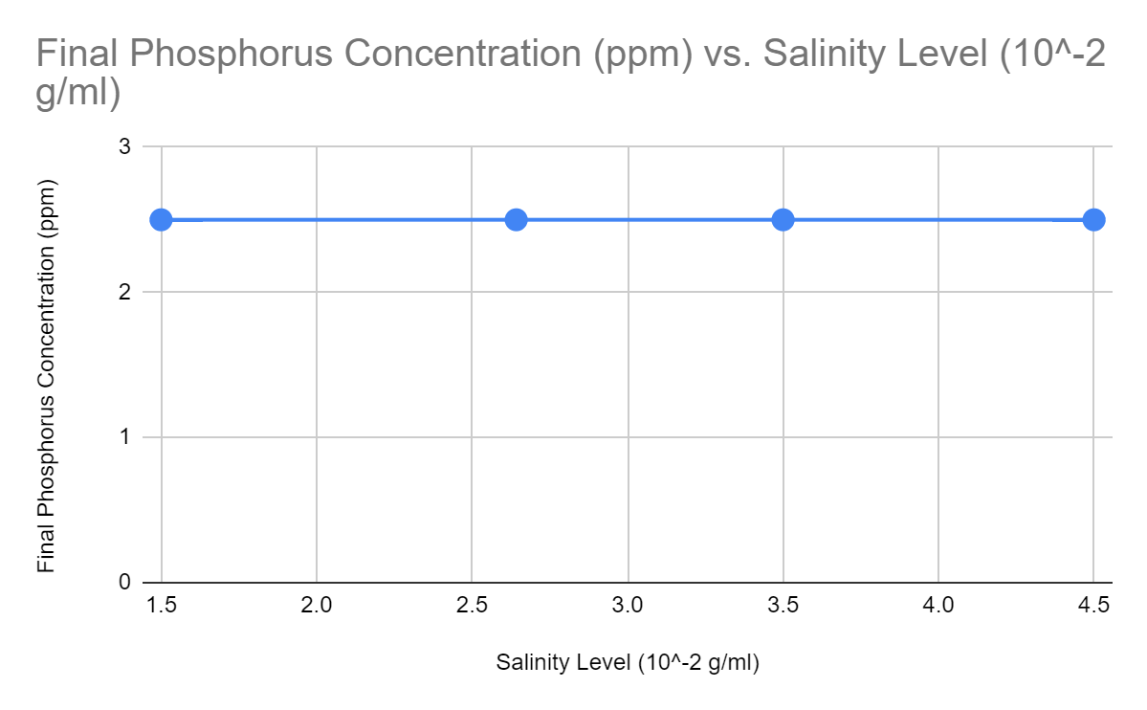

As can be seen in the graph, there is no correlation between final phosphorus concentration, and hence the amount of phosphorus that is removed from the environment, and the salinity level of the culture. The uncertainty of the measurement device is included in the graph, however, because it is very low (0.01 ppm), the error bars are not visible at the scale of the axes. As there is no change in the phosphorus concentration across the salinity levels, the line of best fit, as well as the minimum and maximum slopes are equivalent to the trendline shown on the graph.

# Conclusion

It is difficult to draw a conclusion from this experiment, as there were many factors that impacted the adequate collection and processing of data. However, in terms of the data collected, it can be stated that it does not support the hypothesis, as the hypothesis predicted a positive linear relationship between the variable, however, a relationship with a slope of zero was measured and calculated. This conclusion cannot be generalized outside of this experiment for reasons which will be discussed below.

# Evaluation

## Why it Failed

By all accounts this experiment was a failure, with the main reason being the measurement method used. Based on prior research and calculation, a rough estimate for phosphorus concentration was made at less than two parts per million. This informed the decision for the measurement device used, as a method was required which could measure to that level of precision.

The upper limit of the measurement range for the phosphate checker used is 2.50 ppm, so all of the measurements taken were maxing out the meter’s detection range, meaning that no information about the actual phosphorus content of the cultures was gathered. In an attempt to rectify this, the culture solution was diluted when filling the test cuvette before the initial sensor calibration, however this continued to max out the meter.

## Possible Improvements

### Measurement

In terms of data collection, there are a number of possible solutions. As stated above, the actual phosphorus content of the cultures was much higher than originally estimated. This means that it may be possible to use more conventional phosphorus measurement methods like phosphorus test strips.

It is also possible that the potassium disulfate used in the reagent kits was destructive to the algae cells themselves, and when it was added to the test cuvette, it destroyed the cell membranes releasing the stored phosphorus back into the culture media. If this were the case, then a filtering step could be added before measurement. This could be accomplished by passing the ten milliliters of culture being tested through a layer of filter paper before testing.

Another possible measurement technique could be implemented by performing a titration on the culture. This would most likely also require a filtering step. However, this method would not be preferred as opposed to the others as it can only be performed at the end of the experiment and not at certain time milestones throughout, limiting the amount of data that could be collected, and the usefulness of said data in terms of the research question.

### Other Areas

There are also some other areas for improvement in this experiment, the largest one being that the sample size was relatively small, at only twelve trials. This experiment could be greatly improved with more increments of variation across the independent variable, as well as more trials, and a longer measurement period. Algae cultures develop relatively quickly, however only allowing one week of measurement hinders the usefulness of results. In industrial water filtering applications, algae would be used over the course of many months or years, so a longer measurement window would allow for a more complete idea of how algae cultures will behave in these applications, better answering the research question.

## Further Research Questions

The next step in this research would be to determine if there is a specific species of algae that is better suited to water filtration than another. The *nannochloropsis* species was tested in this experiment, which is a saltwater algae, however it is possible that a freshwater species may be better suited to civil water filtration systems, as they generally have low salinity levels.

# References

Biocyclopedia. (n.d.). *Algae and the Phosphorus Cycle | Roles of Algae in Biogeochemistry | Biogeochemical Role of Algae | Algae*. Biocyclopedia. Retrieved August 28, 2022, from https://biocyclopedia.com/index/algae/biogeochemical_role_of_algae/algae_and_the_phosphorus_cycle.php

Bunce, J. T., Ndam, E., Ofiteru, I. D., Moore, A., & Graham, D. W. (2018, February 22). *A Review of Phosphorus Removal Technologies and Their Applicability to Small-Scale Domestic Wastewater Treatment Systems*. Frontiers. https://doi.org/10.3389/fenvs.2018.00008

*f/2 Media*. (n.d.). Algae Research Supply. Retrieved December 1, 2022, from https://algaeresearchsupply.com/pages/f-2-media

Kroiss, H., Rechberger, H., & Egle, L. (2011, August 23). *Phosphorus in Water Quality and Waste Management*. IntechOpen. https://doi.org/10.5772/18482

Sharpley, A., & Beegle, D. (2001). *Managing Phosphorus for Agriculture and the Environment*. PennState Extension. https://extension.psu.edu/managing-phosphorus-for-agriculture-and-the-environment

Shilton, A. N., Elmetri, I., Drizo, A., Pratt, S., Haverkamp, R. G., & Bilby, S. C. (2006, January). Phosphorus removal by an 'active' slag filter - a decade of full scale experience. *Water Research*, *40*(1), 113-118. https://doi.org/10.1016/j.watres.2005.11.002

Zhao, D., & Sengupta, A. K. (1998, March). Ultimate removal of phosphate from wastewater using a new class of polymeric ion exchangers. *Water Research*, *32*(5), 1613-1625. https://doi.org/10.1016/S0043-1354(97)00371-0

# Appendix A: Experimental Setup

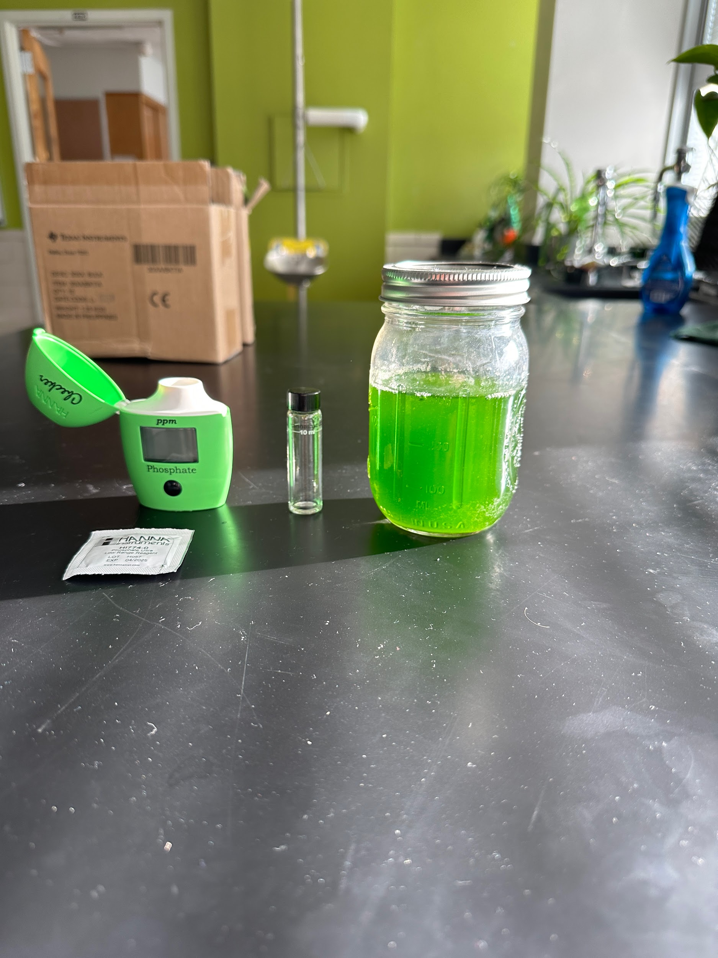

# Appendix B: Raw Data

| Culture Tested | Time (increments of 48 hours) | | | |
| --- | --- | --- | --- | --- |
| 1 | 2 | 3 | 4 |
| Low Trail 1 | 2.50 | 2.50 | 2.50 | 2.50 |
| Low Trail 2 | 2.50 | 2.50 | 2.50 | 2.50 |
| Low Trail 3 | 2.50 | 2.50 | 2.50 | 2.50 |
| Control Trial 1 | 2.50 | 2.50 | 2.50 | 2.50 |
| Control Trial 2 | 2.50 | 2.50 | 2.50 | 2.50 |
| Control Trial 3 | 2.50 | 2.50 | 2.50 | 2.50 |
| Moderate Trail 1 | 2.50 | 2.50 | 2.50 | 2.50 |
| Moderate Trail 2 | 2.50 | 2.50 | 2.50 | 2.50 |
| Moderate Trail 3 | 2.50 | 2.50 | 2.50 | 2.50 |
| High Trial 1 | 2.50 | 2.50 | 2.50 | 2.50 |
| High Trial 2 | 2.50 | 2.50 | 2.50 | 2.50 |
| High Trial 3 | 2.50 | 2.50 | 2.50 | 2.50 |